**Measure Energy Consumption:**

* pyJoules is a software toolkit to measure the energy footprint of a host machine along the execution of a piece of Python code. It monitors the energy consumed by specific device of the host machine such as : intel CPU socket package.

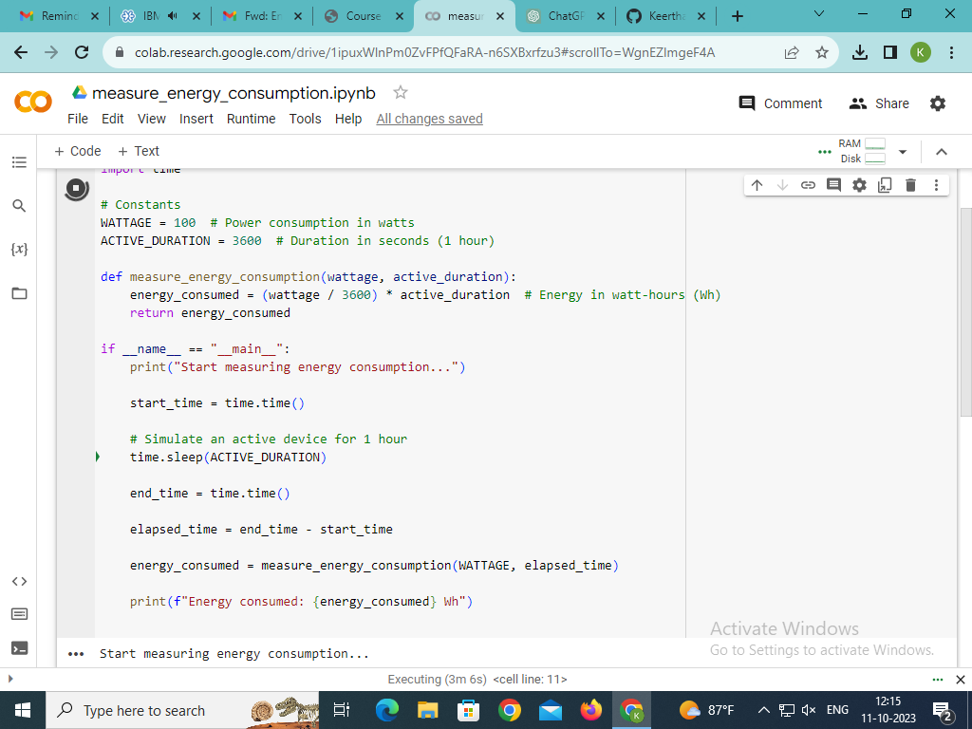

**GitHub Link : https://github.com/Keerthana-192003/Measure-Energy-Consumption.git**